1. **Paramertarize script by using Data Table parameter.**

To parameterize script first we need to record script

Before recording the script need to identify scenario that need to be automated.

Select login functionality of Flight Reservation application.

Steps for Login

**1)** Enter Valid Agent Name in Agent name field

**2)** Enter Valid Password in Password field

**3)**Press Ok button

**4)** Close Application after Successful Login

Let’s start recording

Open quick test Start🡪All programs🡪Quick test professional🡪

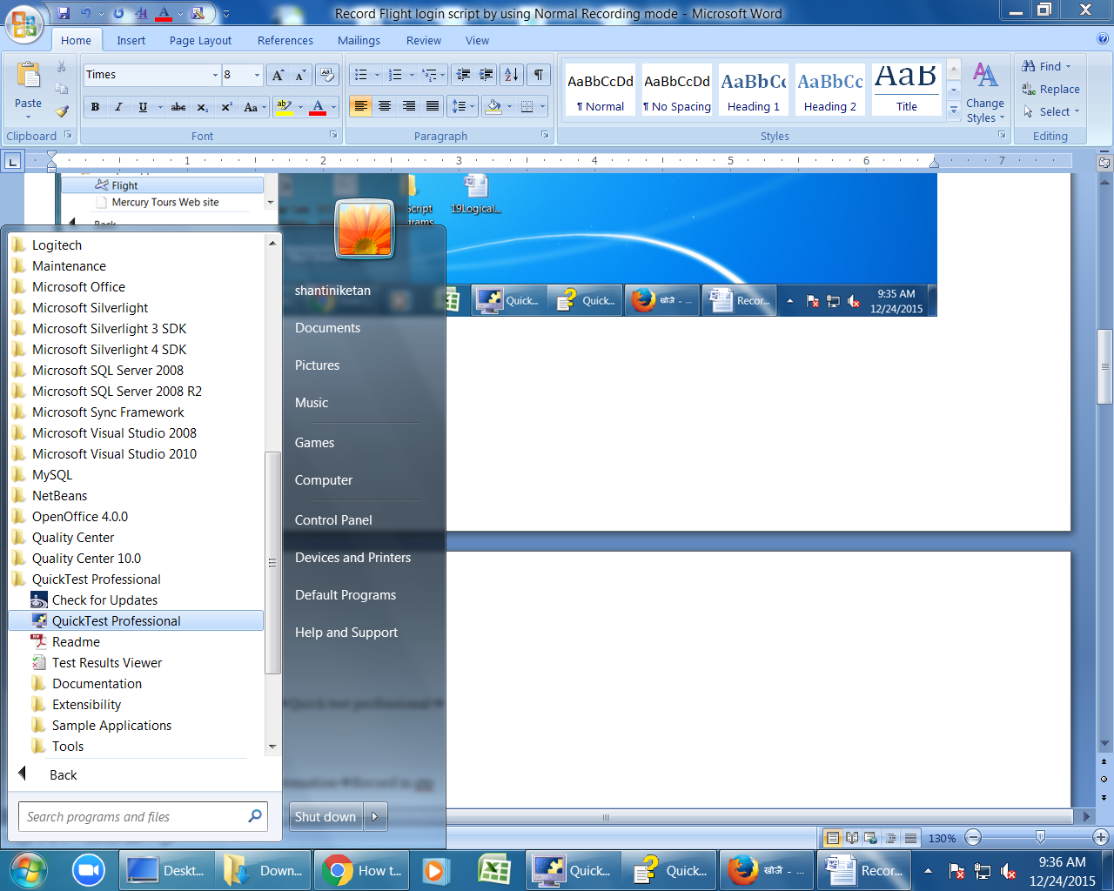

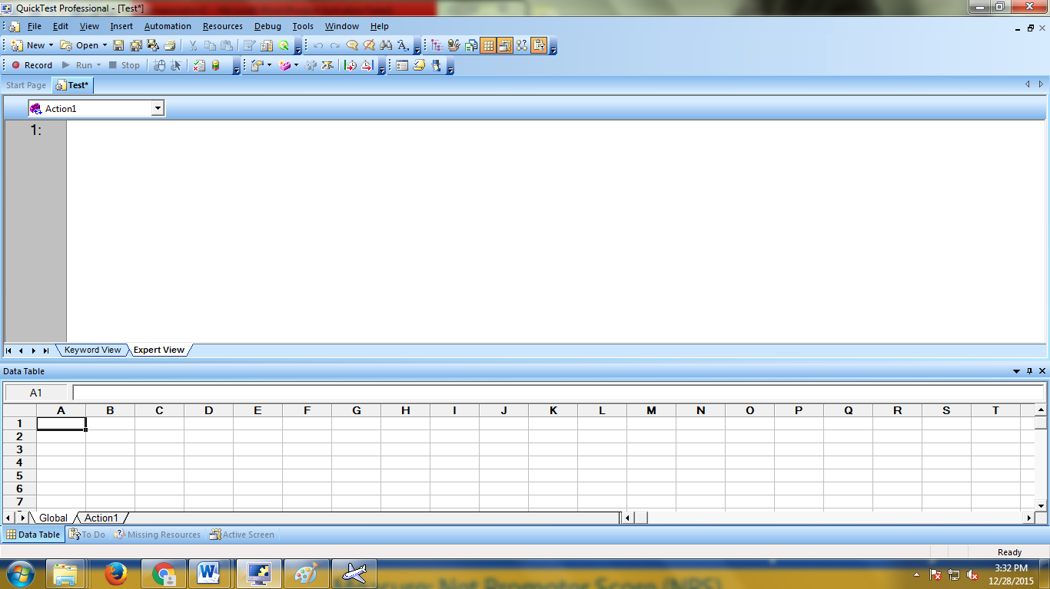

Write Script to Launch Flight login in expert view as Invokeapplication”path of application”

Ex:

Invokeapplication"C:\Program Files\HP\QuickTest Professional\samples\flight\app\flight4a.exe"

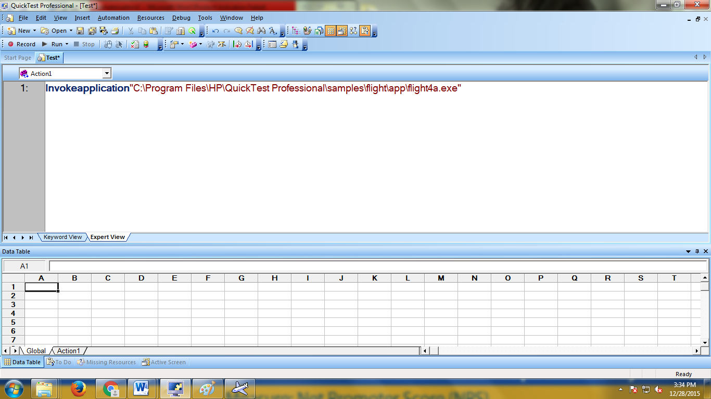

Click on Run button (Quick test open Flight login page)

click on “record” button or (F3) or Automation🡪Record in qtp

The Record & Run settings Dialog Box Opens.

Select windows tab & It contains 2 options.

1) Record & Run on any open window based application

2)Record & Run on a specific window

Select First option (Record & Run on any open window based application) & click on ok

1.Enter Agent Name as “ramesh” in flight login window

2.Enter password as "mercury"

3. Click on "OK"

4. Close flight Reservation window.

Click on "Stop" button or press "F4" to stop recording.

To save test click the save button or select file🡪save

Then you can see below script generated in "Expert View" in QTP

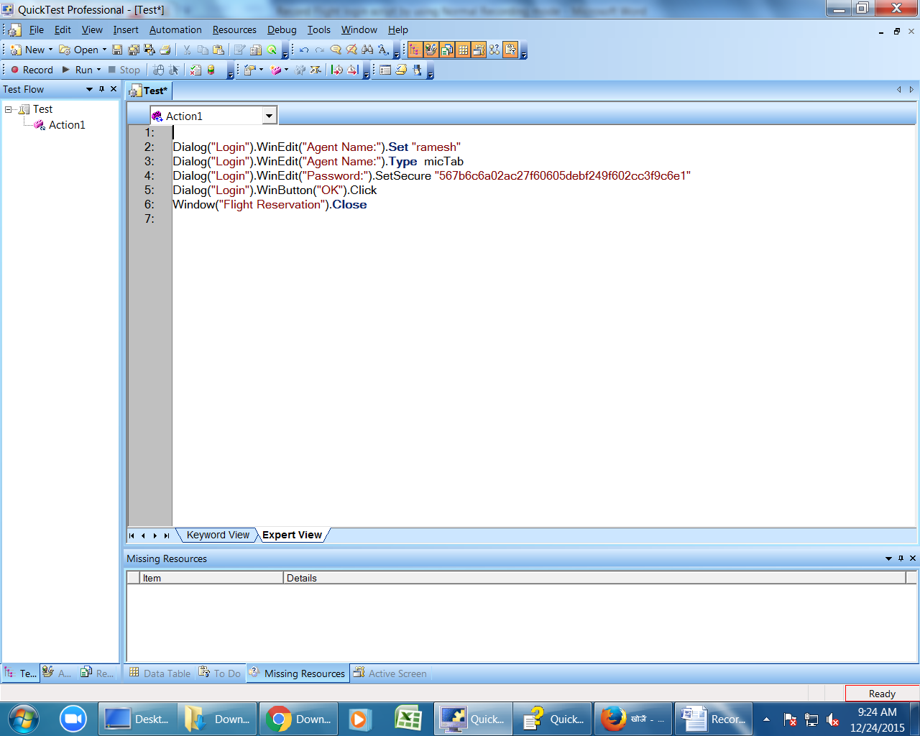

To paramerization of agent name field in script

Select Tools🡪Data Driver

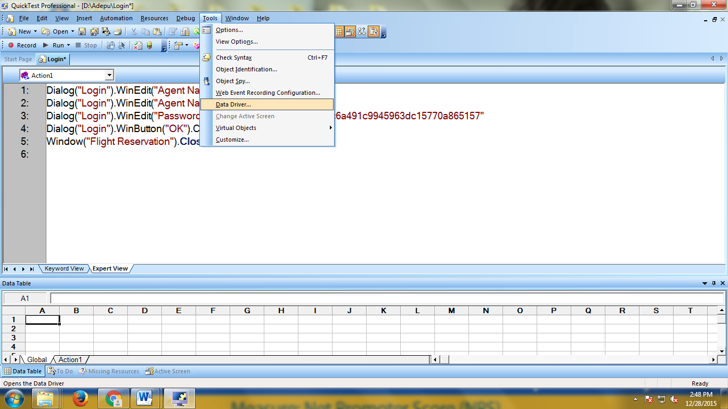

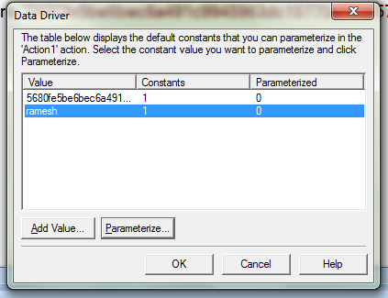

Select Agent name constant value & click on “Parameterize”

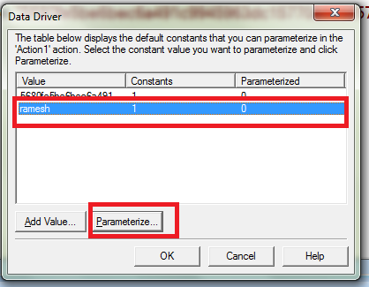

Select “step by step paramerizatio option and click on next

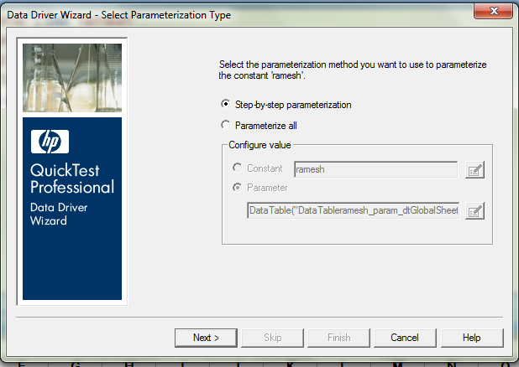

Click on “Parameter Option”

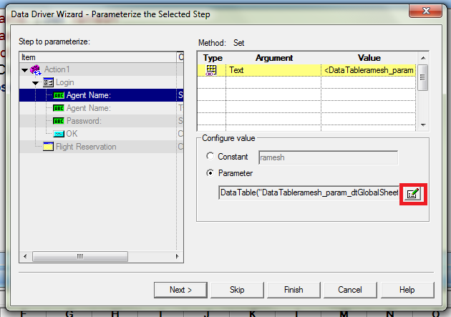

Select Parameter Type as “data table” enter column name as “Agent Name” and click on ok button

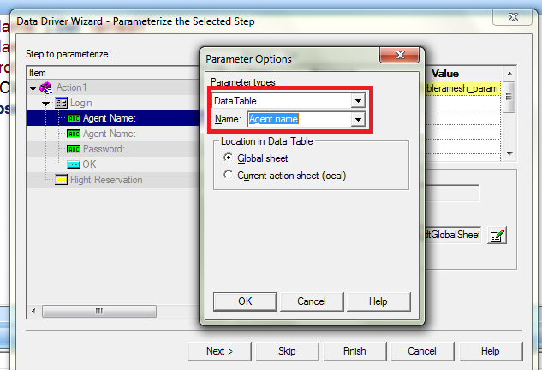

New column creates in datatable as shown in below & click on next button

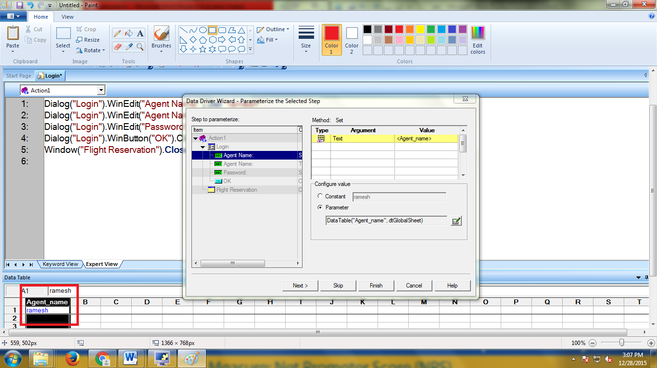

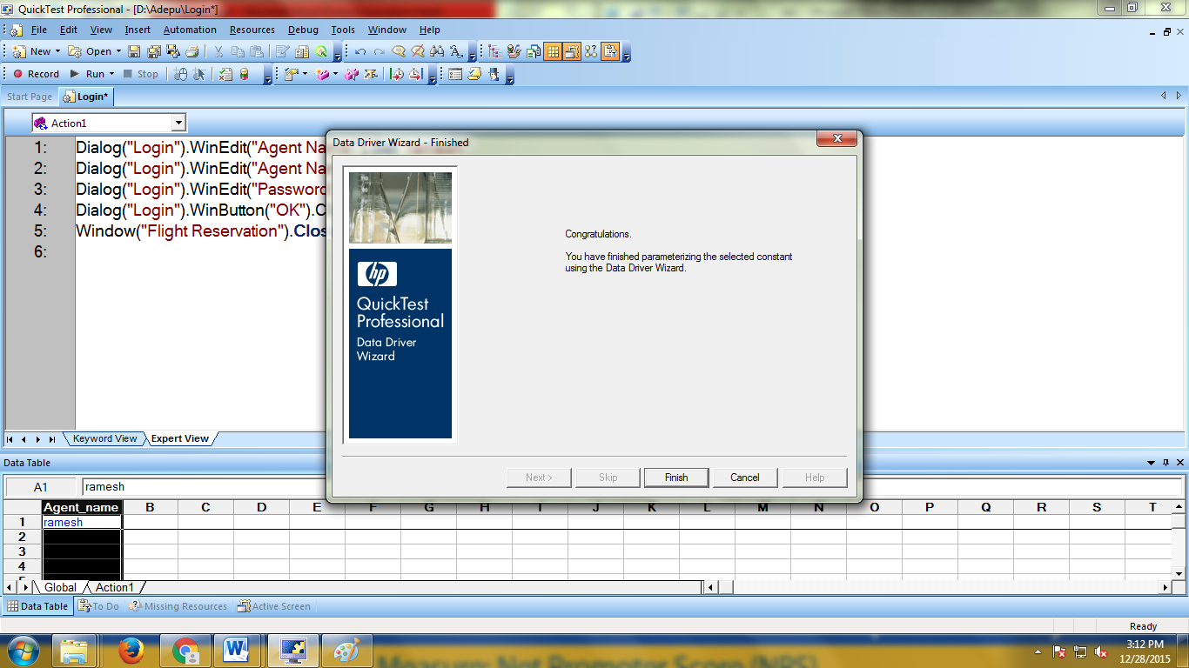

Click on “finish” button

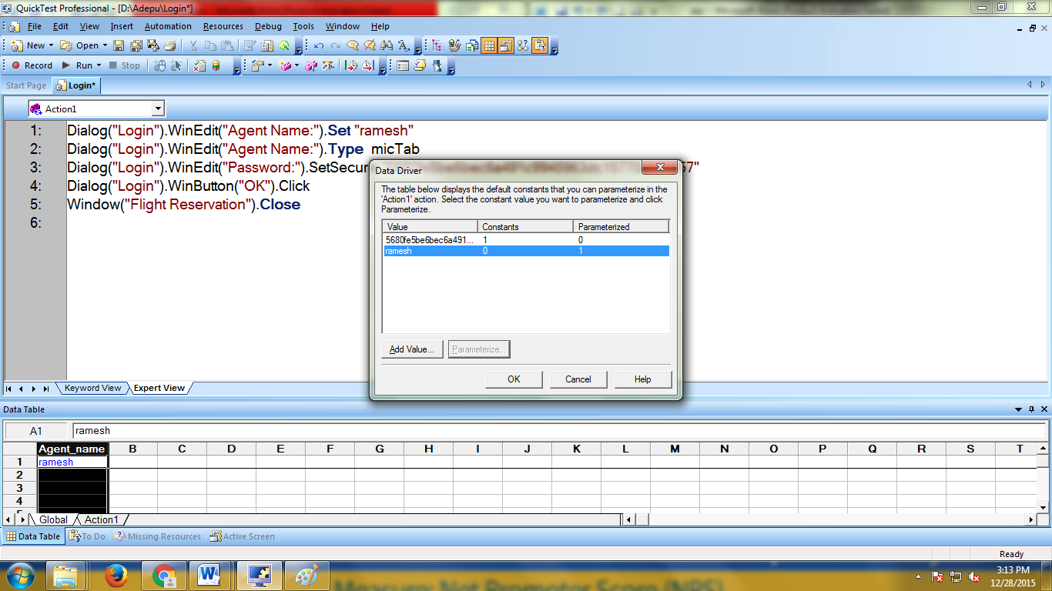

Click on Ok button ( parameterized object script changes in expert view as shown in below)

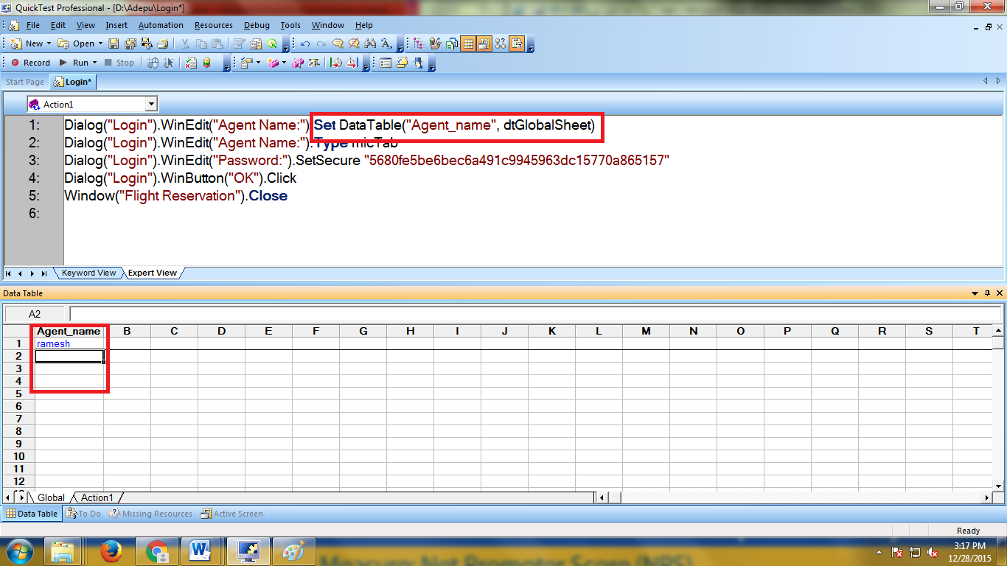

Enter different Agent names in Agent name column in datable

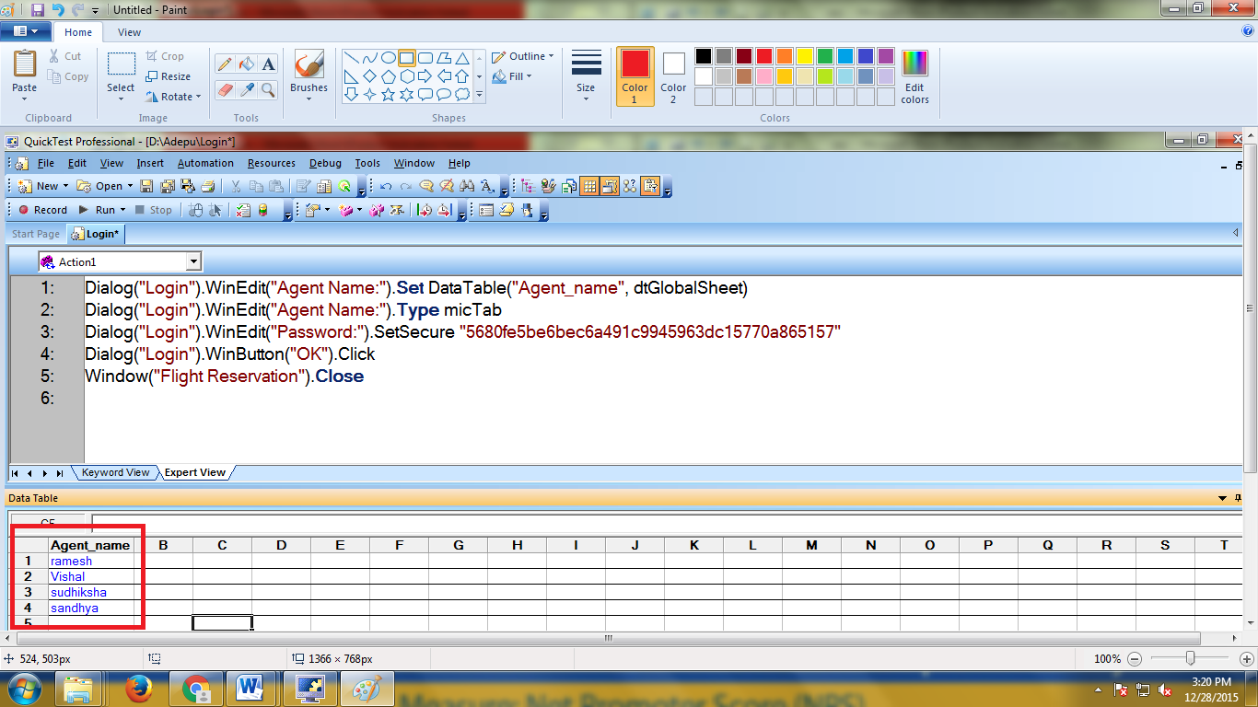

Click on run button (Automation🡪Run or F5)

**Use Environment Parameter in flight login Script**

To parameterize script first we need to record script

Before recording the script need to identify scenario that need to be automated.

Select login functionality of Flight Reservation application.

Steps for Login

**1)** Enter Valid Agent Name in Agent name field

**2)** Enter Valid Password in Password field

**3)**Press Ok button

**4)** Close Application after Successful Login

Let’s start recording

Open quick test Start🡪All programs🡪Quick test professional🡪





Write Script to Launch Flight login in expert view as Invokeapplication”path of application”

Ex:

Invokeapplication"C:\Program Files\HP\QuickTest Professional\samples\flight\app\flight4a.exe"



Click on Run button (Quick test open Flight login page)

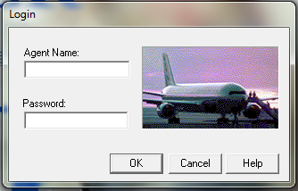

click on “record” button or (F3) or Automation🡪Record in qtp

The Record & Run settings Dialog Box Opens.

Select windows tab & It contains 2 options.

1) Record & Run on any open window based application

2)Record & Run on a specific window

Select First option (Record & Run on any open window based application) & click on ok

1.Enter Agent Name as “ramesh” in flight login window

2.Enter password as "mercury"

3. Click on "OK"

4. Close flight Reservation window.

Click on "Stop" button or press "F4" to stop recording.

To save test click the save button or select file🡪save

Then you can see below script generated in "Expert View" in QTP



Paramerization of agent name field by using environment variable

Select Tools🡪Data Driver





Select Agent name constant value & click on “Parameterize”



Select “step by step paramerizatio option and click on next



Click on “Parameter Option”



Select Parameter Type as “Environment” & Select environment variable name as “username”, value is “Pavani” , Type is Built-in

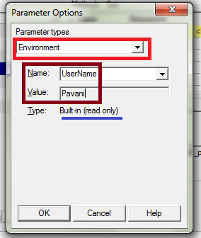

Click on “Ok “ button

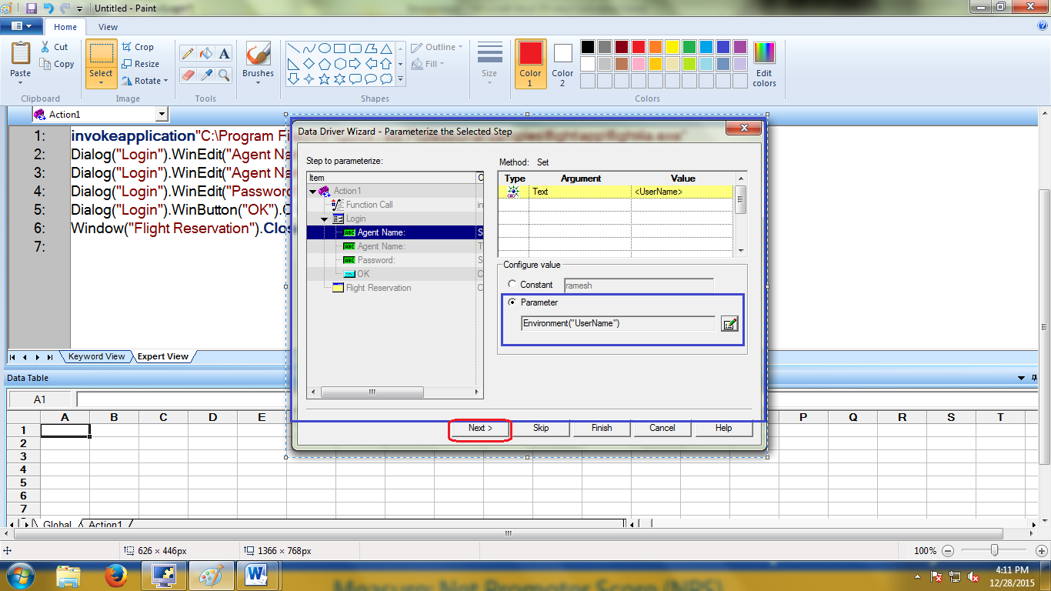

Click on “next “

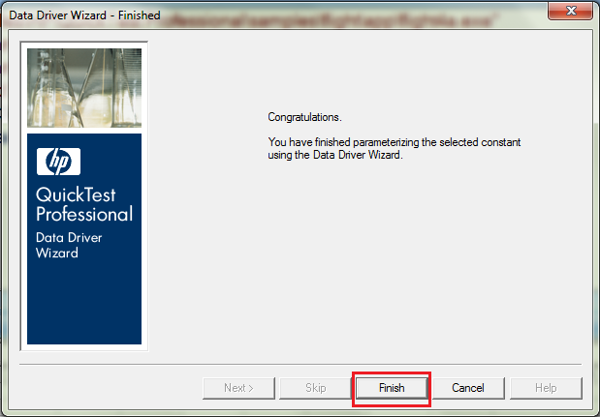

Click on “finish” button

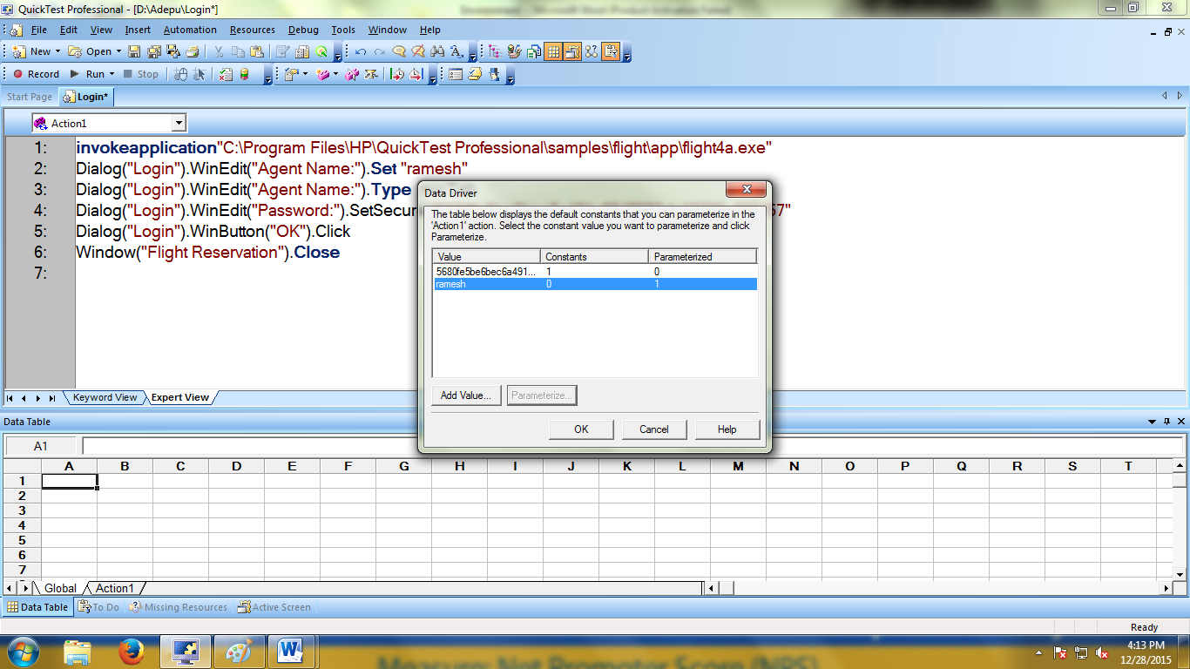

Click on Ok button ( parameterized object script changes in expert view as shown in below)

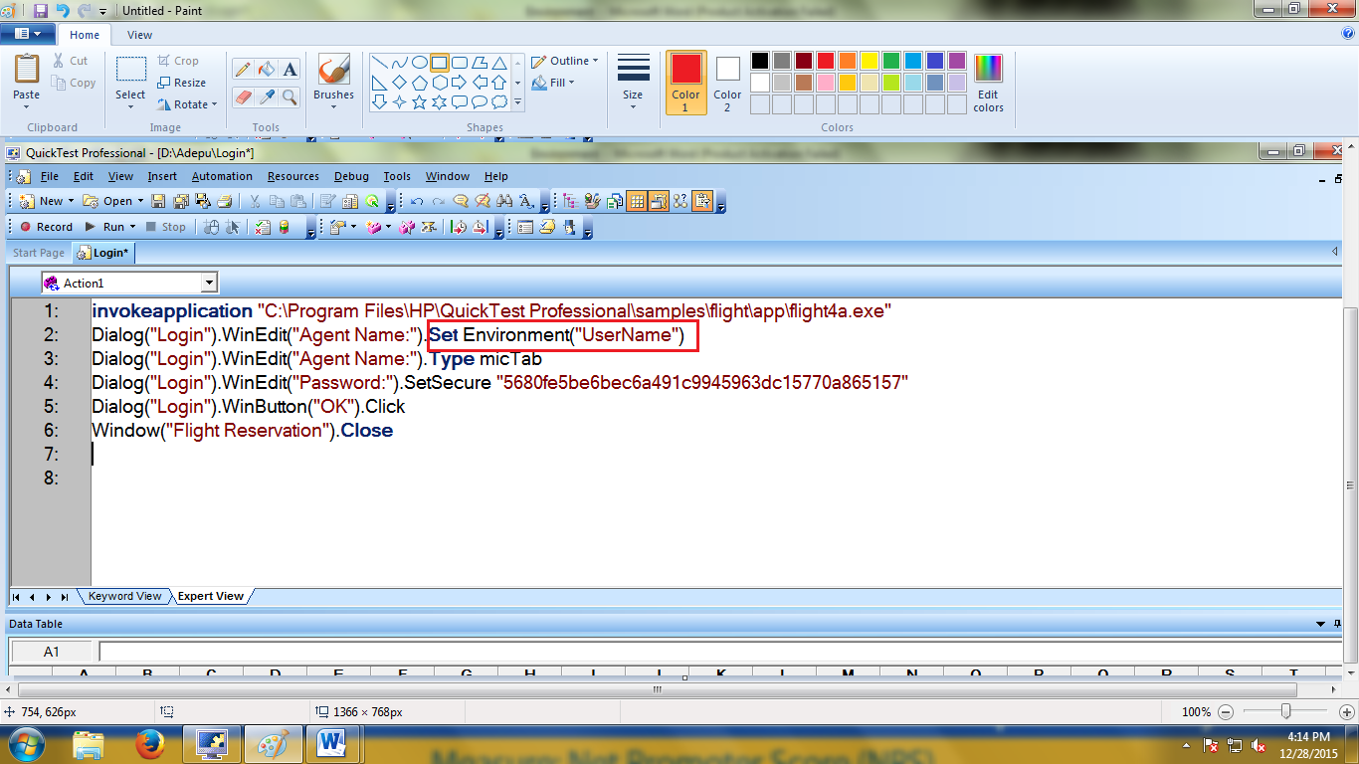

Click on run button. While executing qtp will use agent name value from environment variable. i.e Pavani.

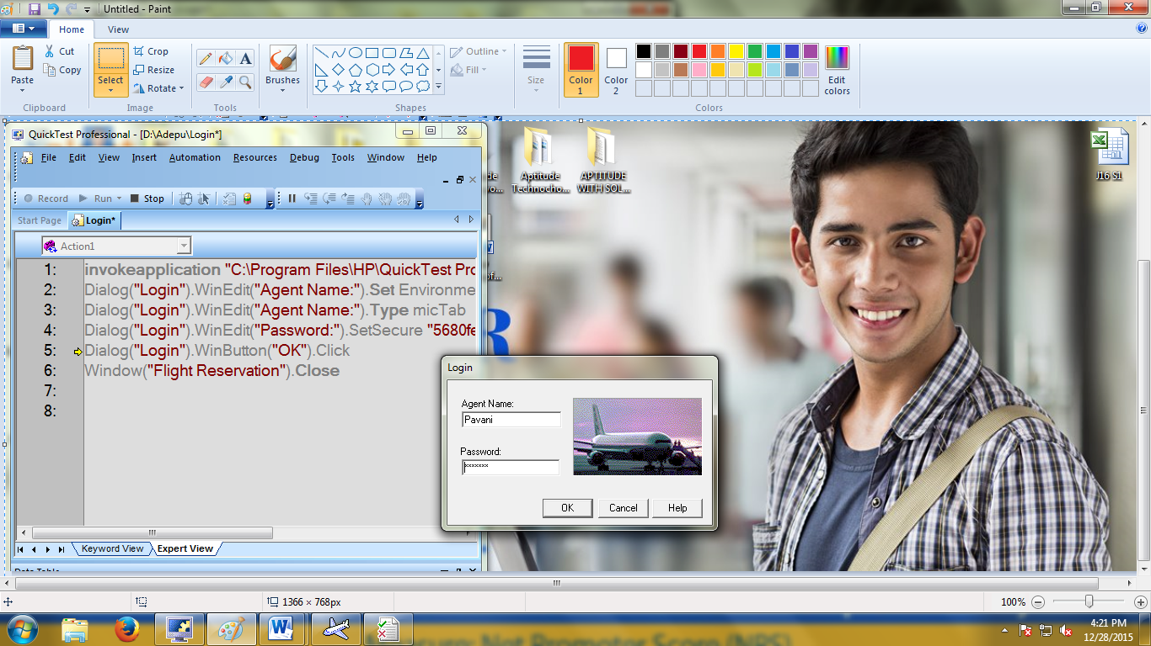

**Paramertarize script by using Random number paramerization.**

To parameterize script first we need to record script

Before recording the script need to identify scenario that need to be automated.

Select login functionality of Flight Reservation application.

Steps for Insert Order in Flight application

**1)** Enter Valid Agent Name in Agent name field

**2)** Enter Valid Password in Password field

**3)**Press Ok button

4) enter date

5) Select Flight From

6) Select Flight To

7) Select the flight

8) Enter Customer name

9) Select class as Bussiness

10) select tickets

11).Click on ok buttom

**12)** Close Application after Successful Login

Let’s start recording

Open quick test Start🡪All programs🡪Quick test professional🡪





Write Script to Launch Flight login in expert view as Invokeapplication”path of application”

Ex:

Invokeapplication"C:\Programes\HP\QuickTestProfessional\samples\flight\app\flight4a.exe"



Click on Run button (Quick test open Flight login page)

click on “record” button or (F3) or Automation🡪Record in qtp

The Record & Run settings Dialog Box Opens.

Select windows tab &It contains 2 options.

1) Record & Run on any open window based application

2)Record& Run on a specific window

Select First option (Record & Run on any open window based application) & click on ok

1.Enter Agent Name as “ramesh” in flight login window

2.Enter password as "mercury"

3. Click on "OK"

4) enter date as 12/30/15

5) Select Flight From as “Lodon”

6) Select Flight To as “paris”

7) Select the flight

8) Enter Customer name “Vishal”

9) Select class as Bussiness

10) select tickets as “5”

11).Click on ok buttom

**12)** Close Application after Successful Login

Click on "Stop" button or press "F4" to stop recording.

To save test click the save button or select file🡪save

Then you can see below script generated in "Expert View" in QTP



To paramerization of agent name field in script

Select Tools🡪Data Driver





Select Agent name constant value & click on “Parameterize”



Select “step by step paramerizatio option and click on next



Click on “Parameter Option”



Select Parameter Type as “data table” enter column name as “Agent Name” and click on ok button



New column creates in datatable as shown in below & click on next button





Click on “finish” button



Click on Ok button ( parameterized object script changes in expert view as shown in below)



Enter different Agent names in Agent name column in datable



Click on run button